Immaculate Conception Parish

P O BOX 600 Tumut
Catholic Community
Collection amounts for January 2016 ~PARISH NEWS~
~ PARISH NEWS ~
~ GOSPEL REFLECTION ~

Trinity Sunday celebrates the core Christian conviction that God is not just one, but also three-in-one. For the people of Israel, no other god could compare with their God whom they knew as both creator and liberator and whom they experienced as intimately involved in every aspect of their history and of their day-to-day lives. In a world of many gods, the assertion found in today’s first reading from Deuteronomy that “there is no other” god was an enormous claim to make. God’s sustaining and liberating presence brought with it serious responsibilities: keeping God’s commandments grounded the people of Israel and their descendants in the life of their God.
The earliest Christians inherited the Jewish belief in one God. At the same time, Christians expressed their faith in distinctively trinitarian language, even if references to all three persons of the Trinity are rarely found in the one passage. Over the first six centuries of the Christian era, the belief that God is three-in-one was to develop into the doctrine of the Trinity which is at the heart of Christian faith. The word Trinity is not used in the Christian Scriptures. In fact, it was not until the end of the fourth century, at the Council of Constantinople in 381, that the doctrine of the Trinity was set out in the creed that is still professed today. The Second Council of Constantinople in 551 used the expression "trinity" to refer to the one essence of God to be worshipped in three persons.
Today’s gospel passage brings Matthew’s gospel to a close. Jesus commands his disciples to make disciples of all peoples and to baptize in the name of the Triune God. At the beginning of this gospel, Jesus is named Emmanuel, “God with us”. With Jesus’ final assurance, “know that I am with you always”, we find ourselves gathered into the very life of God. Perichoresis, a Greek term suggestive of dancing or of figures interweaving, is one of the earliest and probably one of the most striking images used to explain the Trinity. The life that is in God is three and yet one in a totally harmonious dance of equals. The wonder is that we are invited to join the dance. Trinity Sunday is the day we set aside to celebrate the nearness of the God who draws us into the dance of life and love. As St. Paul reminds us, God is not a distant God, but rather a God whose Spirit draws us, as “God’s children” and as “joint heirs with Christ”, into the very communion of the Trinity. An excerpt by Sr. Veronica Lawson

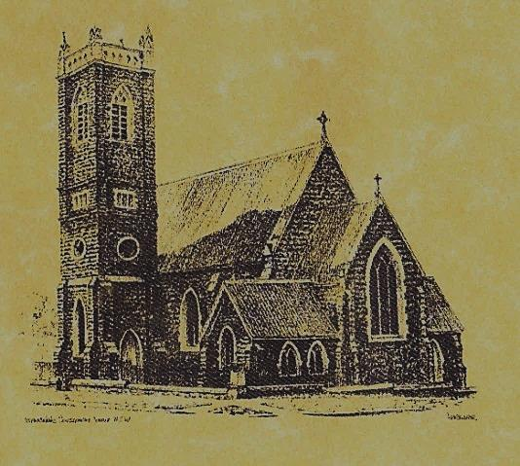

‘CLERGY’
- Fr. Sijo Jose (Parish Priest)
- Fr. George Ogah (Assistant Priest)

‘PARISH SECRETARY’
Anna Quinn
Phone: 02 69474599
Fax: 02 69474602
Email: tumut@cg.org.au
Web: www.cg.org.au/tumut
Office hours: Wednesday & Friday 9am -12noon
-------------------------------------------------------- ‘WEEKEND MASS TIMES’
Saturday Vigil: 6.pm
Sunday: 10am
Talbingo Sunday: 8.am
‘THIS WEEKS MASS TIMES’
Tuesday: 6pm in Chapel
Wednesday: 10am (School Mass)
Thursday & Friday: 8am in Chapel
Saturday: 9am (every fortnight – Thursday: 11am BUPA Liturgy Saturday: 9.40am BLAKENEY LODGE Liturgy)
‘ROSARY’
Saturday at 8.45am Exposition at 8.30asm (1st Sat of month)
‘RECONCILIATION’
Saturday at 5.15pm
‘LITURGY MEETING’
Tuesday: 2.00pm in Chapel
‘PRAYER GROUP’
(Rosary & Divine Mercy)
Wednesday: 2.00pm in Chapel
‘CONTACTS’
Care Group: Anne Huebner 69473406

TRINITY SUNDAY Year B
May 27th 2018

Entrance Antiphon
Blest be God the Father, and the Only Begotten Son of God, and also the Holy Spirit, for he has shown us his merciful love.
Responsorial Psalm
Happy the people the Lord has chosen to be his own.
Gospel Acclamation
Alleluia, alleluia! Glory to the Father, the Son, and the Holy Spirit; to God who is, who was, and who is to come. Alleluia!

Gospel Acclamation
-----------------------------------
Alleluia, alleluia! Tomorrow the wickedness of the earth will be destroyed; the Saviour of the world will be our king. Alleluia!

T THIS WEEK Saturday & Sunday 26th & 27th May

Ministry | Saturday Vigil 6pm | Sunday 10am
Acolyte | Peter Malone | Anne Huebner
Reader | School Mass | Mark Hogan
Commentator | School Mass | Pat Spannagle
Children’s Liturgy | ---------- | Caitlin Larter
Musicians | Anna Quinn | Patricia & Monica
Altar Servers | Abby Crampton & Olivia Dean | Jude Moreno & Hunter Styles
Church Care  ________________________  LINEN Marie Ambrose | Group 4: The Dobbie Family
NEXT WEEK Saturday & Sunday 2nd & 3rd June
Ministry | Vigil 6pm |  | 10am
Acolyte | Tony Butler |  | Anita Mason
Reader | Evelyn Heffernan |  | Kath Rosetta
Commentator | Maureen Cook |  | Mary Kelly
Children’s Liturgy | ---------- |  | Pat Spannagle
Musicians | Patricia & Monica |  | Anna Quinn
Altar Servers | Jessica & Emily Kelly |  | Annabelle Sturgess & Genevieve Mason-Elliott
Church Care | -------------------------------------
Feast DayWishing all our wonderful dads a Happy In m
R O S T E R S
FEAST DAY ~ 1st June: Saint Justin
God does not change; he is Love, ever and always, In himself, he is communion, unity in Trinity, and all his words and works are directed to communion. Pope Benedict XVI
~PARISH NEWS~
PREPARATION FOR CONFIRMATION there will be 2 information evenings relating to this sacrament the first being this Saturday 26th May and the second on Saturday 2nd June at 5pm for candidates and parents to attend followed by the 6pm Vigil Mass. The sacrament of Confirmation will be celebrated on Saturday 23rd June at the 6pm Vigil Mass.
PLENARY COUNCIL 2020 –Listen to what the Spirit is saying. Pope Francis has approved the Australian Bishops’ decision to hold a Plenary Council in Australia in 2020 & 2021. It is a significant moment for the Church in Australia to make decisions about the future. To find out more about this Council go to www.plenarycouncil.catholic.org,au
SPECIAL THANKS to our McAuley Stage 3 students and teachers for presenting our Vigil Mass this weekend.

We pray for those who have gone before us marked with the sign of faith:
MASS HAS BEEN REQUESTED FOR:
Imelda, Bede & Francis McInerney, Cecilia Haddah, John Hourigan, Russell & Peter Ritchie, Kerry Letts, Filomena Comai, Eileen Creighton, Muriel Maidwell, Thomas Maidwell, Margaret Anne Reardon, Steph Scott, Peter Bush, Alan Guthrie, Jim McInerney, Kath Stuckey, Iris Stuckey, Minnie Murphy, Alfred & Bridget Claffey, John Marzol, Joan & Pat Cronmy, Sean Gordon, Maureen Ashleigh, Kade Adams, Tom Sturt, Winifred Whitacker, Edward,Mary & Clem Malone, Pat Malone, Hickson & O’Sullivan families, Colleen Anderson, Reg & Mary Madigan, Matt Downing, Wilkinson & Downing families, Frank Stanfield, Peter Heffernan, Tim & Amy Twomey, Barbara Fuller, Tom & Merle Arentz, Harriet & Ruben Arentz, Kevin & Nola Arentz, Dulcie & Arthur Piper, Marie & Ray Cowan, Kevin Cowan, Kevin Hawthorne, Natalie Baker, Ian Barbour, Fr. Peter Quirk, Con & Ennis Twomey, Mons.John Twomey, Sr. M. Brenda Twomey, Sr. M. Canice O’Sullivan, Sr. M. Celine McCormack, Bert & Teresa Butler, Anne Lawrance, Joan & Bob Liddell, Mary & William Claffey, Ruby Harmer, Hassel & Joy McGrath, Noel Cook, Hargreaves family, Family members & relatives of Tran family, Frederick & Mabel McInerney, James Kelly, Tom & Dorothy French.

